Types of ARP Entries
# Source: AI Source: Provided by: [Data Path: Persons Table -> ID Column: 1, Name_En Column: Motasem Essam] -> From: [ChatGPT] on [1/16/2026]
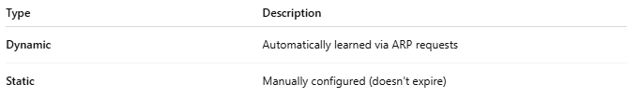
Type | Description
Dynamic | Automatically learned via ARP requests
Static | Manually configured (doesn't expire)

